**SQL Joins assignment**

**Database Schema**

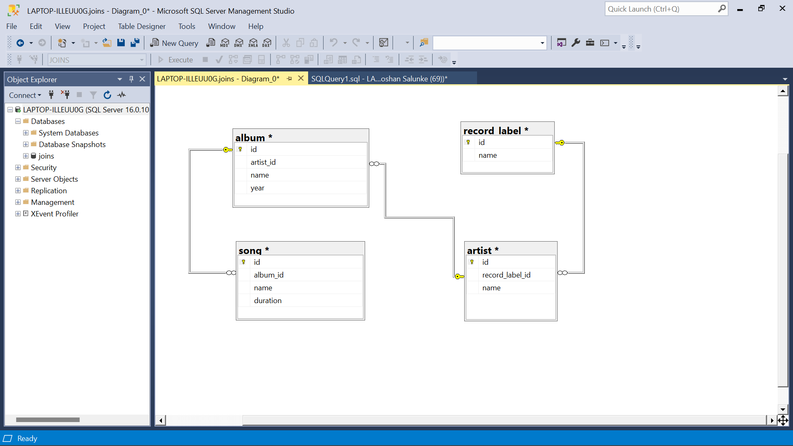

Initial queries for database, table creation and inserting values

Create and use database

create database joins;

use joins;

Create Tables

CREATE table album (id int, artist_id int, name varchar(100), year int)

CREATE table song (id int, album_id int, name varchar(50), duration float(20))

CREATE table record_label (id int, name varchar(50))

CREATE table artist (id int, record_label_id int, name varchar(50))

Inserting Values

INSERT INTO album (id, artist_id, name, year) VALUES(1, 1, 'Devils got a new disguise', 2006),

(2,1,'Keeps getting better',2008),

(3, 1,'Master of Puppets',1986),

(4, 2,'Endgame',2009),

(5, 2,'Icon',2012),

(6,3,'Story',2000),

(7,4,'Chapters',2003),

(8,4,'Riding with the King',2000),

(9,5,'Pieces of a Dream',2005),

(10,6,'Greatest Hits',2004),

(11,7,'All-Time Greatest Hits',1975),

(12,8,'Greatest Hits',1983),(13,9,'Ultimate Collection',2015)

INSERT INTO song (id, album_id, name, duration) VALUES(1,1,'Dream On',4.26),(2,1,'Back in the Saddle',4.40),

(3,2,'Genie in a Bottle',5.3),

(4,2,'Beautiful',5.29),

(5,3,'Master of Puppets',8.35),

(6,3,'Battery',5.13),

(7,4,'Dialectic Chaos',2.26),

(8,4,'Endgame',5.57),

(9,5,'Watching Airplanes',4.03),

(10,5,'Man to Man',3.41),

(11,6,'Balck Winter Day',3.48),

(12,6,'Against Widows',4.04),

(13,7,'Reptile',3.36),

(14,7,'Modern Girl',4.49),

(15,8,'Riding with the King',4.23),

(16,8,'Key to the Highway',3.39),

(17,9,'Im Outta Love',4.02),

(18,9,'Not That Kind',3.20),

(19,10,'Eruption',1.43),

(20,10,'Hot For Teacher',4.43),

(21,11,'Sweet Home Alabama',4.45),

(22,11,'Free Bird',14.23),

(23,12,'Thunderstruck',4.52),

(24,12,'T.N.T',3.35),

(25,13,'Sgt. Pepper''s Lonely Hearts Club Band',2.0333),

(26,13,'With a Little Help from My Friends',2.7333),

(27,13,'Lucy in the Sky with Diamonds',3.4666),

(28,13,'Getting Better',2.8),(29,13,'Fixing a Hole',2.6),

(30,13,'Shes Leaving Home',3.5833),

(31,13,'Being for the Benefit of Mr. Kite!',2.6166),

(32,13,'Within You Without You',5.066),

(33,13,'When I''m Sixty-Four',2.6166),

(34,13,'Lovely Rita',2.7),

(35,13,'Good Morning Good Morning',2.6833),

(36,13,'Sgt. Pepper''s Lonely Hearts Club Band (Reprise)',1.3166),

(37,13,'A Day in the Life',5.65)

INSERT INTO record_label (id, name) VALUES(1,'Blackened'),

(6,'Capitol'),

(5,'Elektra'),

(4,'MCA'),

(3,'Universal'),

(2,'Warner Bros')

INSERT INTO artist (id, record_label_id, name) VALUES(3,1,'Anthrax'),

(2,1,'Christina'),

(1,1,'Aerosmith'),

(4,2,'Eric Clapton'),

(6,2,'Amorphis'),

(5,2,'Gary Allan'),

(8,3,'AC/DC'),

(7,3,'Lynyrd Skynyrd'),

(9,6,'Anastacia')

Assignment Questions

Q1. Show all the 4 tables(album, song, record label and artist)

Select * from album;

Select * from song;

Select * from record_label;

Select * from artist;

Output:-

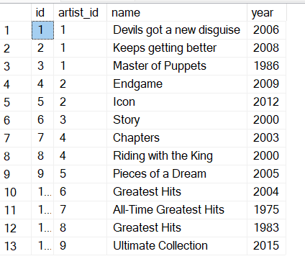

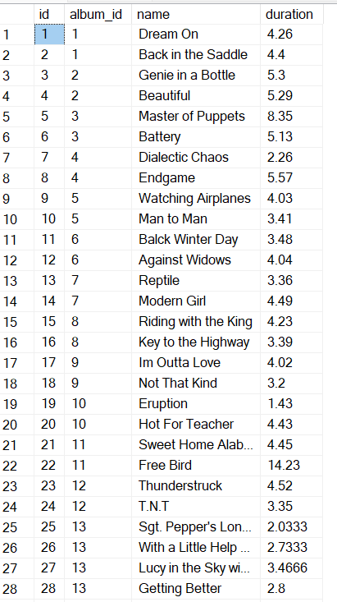

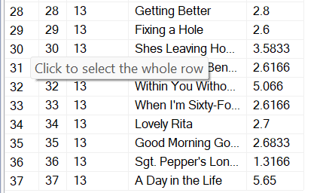

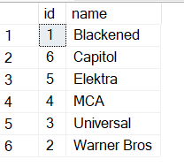

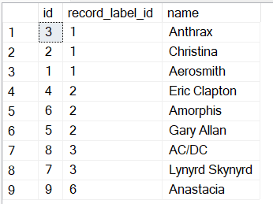

2 List all artists for each record label sorted by artist name.

select a.name , rl.name from artist a left join record_label rl on a.record_label_id=rl.id order by a.name;

Output:

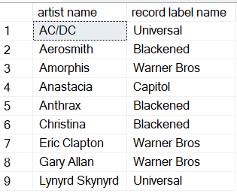

3.Which record labels have no artists?

select rl.name from record_label rl left join artist a on a.record_label_id=rl.id where a.record_label_id is null;

Output:

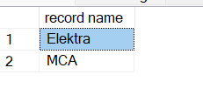

4. List the number of songs per artist in descending order

select ar.name ,count(*) as 'Number_of_songs' from song s join album al on al.id=s.album_id join artist ar on ar.id=al.artist_id group by ar.name order by count(*) desc;

Output:

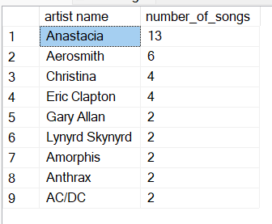

5. Which artist or artists have recorded the most number of songs?

select top 1 ar.name ,count(*) as 'Number_of_songs' from song s join album al on al.id=s.album_id join artist ar on ar.id=al.artist_id group by ar.name order by count(*) desc;

Note: In Microsoft Server Studio use top n instead of limit

Output:

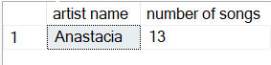

6.Which artist or artists have recorded the least number of songs?

select top 5 ar.name ,count(*) as 'Number_of_songs' from song s join album al on al.id=s.album_id join artist ar on ar.id=al.artist_id group by ar.name order by count(*) ;

Output:

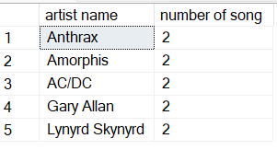

7.which artists have recorded songs longer than 5 minutes, and how many songs was that?

select ar.name ,count(*) as 'Number_of_songs' from song s join album al on al.id=s.album_id join artist ar on ar.id=al.artist_id where s.duration >5 group by ar.name ;

Output:

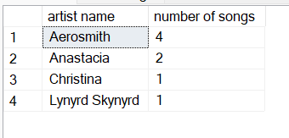

8.for each artist and album how many songs were less than 5 minutes long?

select ar.name ,al.name,count(*) as 'Number_of_songs' from song s join album al on al.id=s.album_id join artist ar on ar.id=al.artist_id where s.duration <5 group by ar.name ,al.name;

Output:

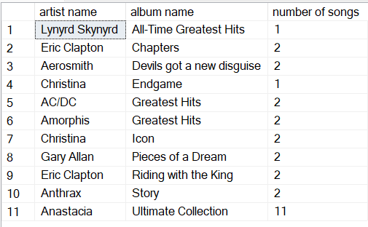

9.In which year or years were the most songs recorded?

select top 1 al.year ,count(*) as 'Number_of_songs' from song s join album al on al.id=s.album_id group by al.year order by count(*) desc;

Output:

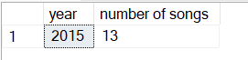

10. list the artist, song and year of the top 5 longest recorded songs

select top 5 ar.name,al.name,s.name ,al.year,s.duration as 'Number_of_songs' from song s join album al on al.id=s.album_id join artist ar on ar.id=al.artist_id order by s.duration desc;

Output:

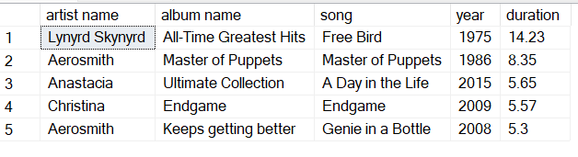

11.Number of albums recorded for each year

select year , count(name) as 'No of albums' from album group by year;

Output:

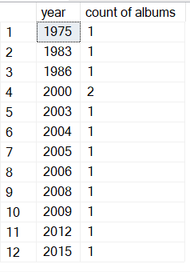

12. What is the max number of recorded albums across all the years?

with temp as (select top 1 year , count(name) as 'No_of_albums' from album group by year order by count(name) desc) select No_of_albums as 'Max number of albums recorded' from temp;

-- Hint: using the above sql as a temp table

Output:

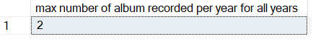

13. In which year (or years) were the most (max) number of albums recorded, and how many were recorded?

-- Hint: using the above sql as a sub-select

with temp as (select top 1 year , count(name) as 'No_of_albums' from album group by year order by count(name) desc) select year,No_of_albums as 'Max number of albums recorded' from temp;

Output:

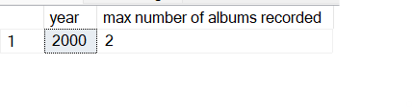

14. total duration of all songs recorded by each artist in descending order

select ar.name ,sum(s.duration) as 'Total duration of songs' from song s join album al on al.id=s.album_id join artist ar on ar.id=al.artist_id group by ar.name order by sum(s.duration) desc;

Output:

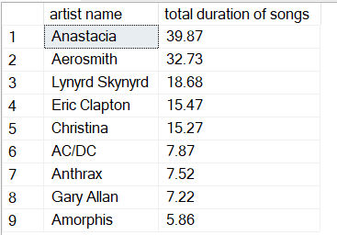

15.for which artist and album are there no songs less than 5 minutes long?

select ar.name as 'Artist name',al.name as 'album name' from artist ar left join album al on ar.id=al.artist_id left join song s on al.id=s.album_id and duration <5 where s.name is null ;

Output:

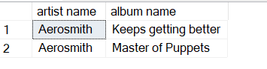

16. Display a table of all artists, albums, songs and song duration -- all ordered in ascending order by artist, album and song

select ar.name , al.name,s.name,s.duration from song s join album al on al.id=s.album_id join artist ar on ar.id=al.artist_id order by ar.name , al.name,s.name;

Output:

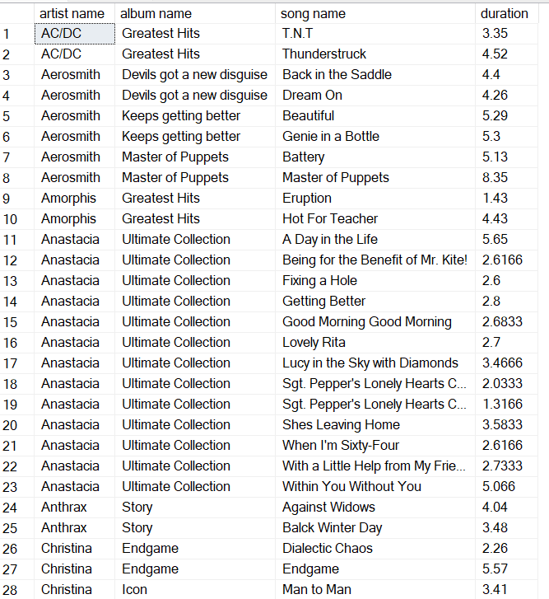

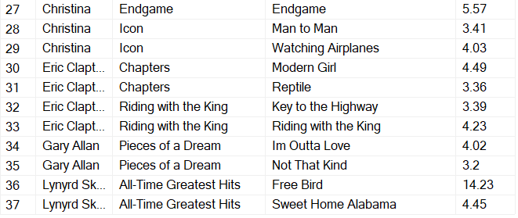

18. Total album length for all songs on the Greatest hits album - in minutes and seconds

select al.name 'Album Name',

case

when round( (sum(s.duration) -cast(sum(s.duration) as int)) ,2)>0.60 then cast(sum(s.duration) as int)+1 else cast(sum(s.duration) as int)

end as 'minutes',

case when round( (sum(s. duration) -cast (sum(s.duration) as int)), 2)>0.60

then (round((sum(s.duration)-cast(sum(s.duration) as int)),2)-0.60) *100

else (round((sum(s.duration) -cast(sum(s.duration) as int)),2))*100 end as 'seconds'

from album al join song s on s.album_id = al.id where al.name like

'Greatest%' group by al.name;

Output:



19. Which artists did not release an album during the decades of the 1980's and the 1990's?

select distinct ar.name from artist ar left join album a on ar.id=a.artist_id and a.year>=1980 and a.year<=1990 where year is null order by ar.name;

Output:

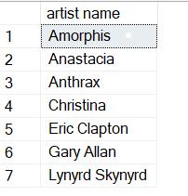

20. Which artists did release an album during the decades of the 1980's and the 1990's?

select distinct ar.name from artist ar left join album a on ar.id=a.artist_id and a.year>=1980 and a.year<=1990 where year is not null order by ar.name;

Output:

